Module 4: Group Products

Lesson 3: Group Retirement Plans

Learning Objectives

After studying this lesson, you will be able to:
- Describe the basic elements of employer-sponsored retirement plans: who is involved, why the plans exist, and why insurers are ideally suited to meet this market need.
- Identify the basic requirements of qualified employer-sponsored retirement plans in the United States.
- Distinguish between defined benefit and defined contribution retirement plans.
- Identify and describe different types of defined contribution plans.
- List and describe retirement plans available to small employers in the United States.

Group Retirement Plans

Learning Objective
Describe the basic elements of employer-sponsored retirement plans: who is involved, why the plans exist, and why insurers are ideally suited to meet this market need.
Open Transcript
Retirement security is an important financial need. Recall individual annuities and individual retirement arrangements (IRAs)? People can purchase those products to provide them with an income after they retire.
In addition, people often receive retirement income from private retirement plans sponsored by employers or labor unions as well as from government programs like the Social Security program in the United States.
What about outside the United States? Countries outside the United States offer combinations of government-sponsored, employer-sponsored, and personal retirement plans.
Can you think of any reasons why insurance companies are well-suited to assisting employers or labor unions with their pension plans?

Insurers and Retirement Business

Insurers have expertise in…
- Long-term investing
- Managing group benefit plans
- Managing the risk associated with lifetime payments

Plan Sponsor
The Stetson Company offers a retirement plan to its employees.
In this arrangement, Stetson is the plan sponsor. The entity that establishes and maintains a retirement plan is usually
- An employer
- A union


Plan Participants
Plan participants can be employees or union members.

Carla says, "We’re plan participants—we’ve chosen to participate in Stetson’s retirement plan."
Insurers seek to satisfy the retirement needs of two different groups—the organizational customer or plan sponsor, and the individual customers or plan participants.

Why do employers offer retirement plans?
^{To attract valuable employees}
For tax advantages for themselves and participating employees
To assist employees in saving for retirement
^{All of these reasons}

Plan Administrator
Carla says,"I’m the plan administrator of our retirement plan. Stetson appointed me to handle the operation of the plan.
"I maintain records, prepare required reports for governmental agencies, and give plan participants information about the plan."


Plan Document
The plan sponsor decides what type of retirement plan to establish and what the terms of the plan will be. The terms of the plan are set out in a legal agreement—the plan document.
Plan participants receive a summary plan description that informs them of their rights under the plan.

Sources of Funds
Retirement plans can have the following sources of funds:
- Contributions made by the plan sponsor
- Contributions made by the plan participants
- Investment/interest earnings on all contributions

Identify all the parties that can serve as the plan sponsor of a group retirement plan. (Choose all that apply.)
^{Employers}
^{Employees}
^{Unions}
Submit
Identify the role(s) of each entity in Stetson’s retirement plan. (Choose all that apply.)

HR Manager Carla Abernathy
^{Plan Sponsor}
^{Plan Administrator}
^{Plan Participant}
Submit
Jerome Tate
^{Plan Sponsor}
^{Plan Administrator}
^{Plan Participant}
The Stetson Company
^{Plan Sponsor}
^{Plan Administrator}
^{Plan Participant}

Employer-sponsored Retirement Plans

Learning Objective
Identify the basic requirements of qualified employer-sponsored retirement plans in the United States.

Qualified Retirement Plans

The U.S. government offers tax advantages to plan participants and to employers that set up retirement plans according to certain guidelines.
To become a qualified plan and receive favorable tax treatment, a plan must meet requirements set out in federal tax laws and the Employee Retirement Income Security Act (ERISA).

ERISA Requirements
What are ERISA requirements? Let’s look at a few of them.
- A qualified retirement plan can’t favor highly compensated employees
- Plan assets must be held in a trust account at a financial institution for the exclusive benefit of employees or their beneficiaries
- The plan sponsor must provide certain reports to plan participants and governmental agencies
- The plan must meet certain minimum vesting requirements regarding a participant’s right to receive plan benefits

Vesting Schedules
Employees are immediately vested in 100 percent of their own retirement plan contributions.
Employer contributions vest according to one of two types of vesting schedules:
- Graded vesting (or step vesting)
- Cliff vesting
Graded Vesting
Stetson Co. employees are vested in 20% of Stetson's contributions after one year. Each year they vest in an additional 20% until they are fully vested in Year 5.
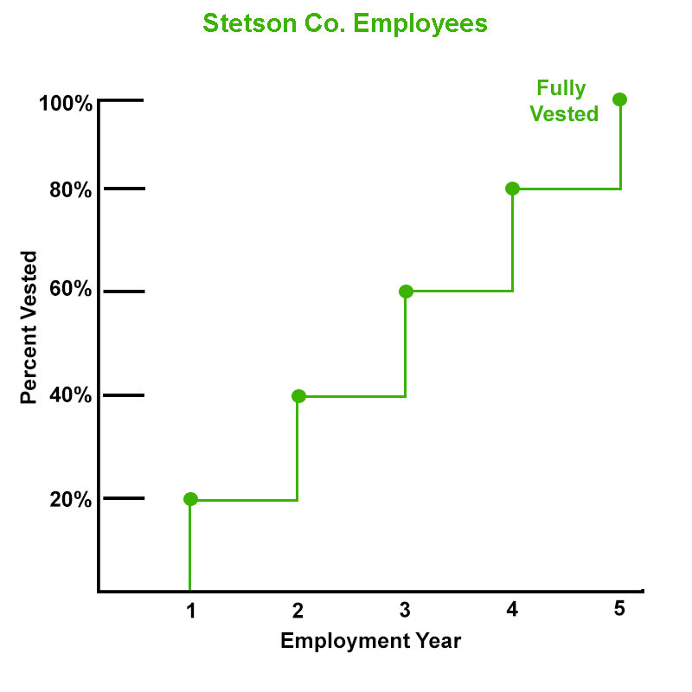
Cliff Vesting
Dosun Engineering employees have no vested interest in the employer's contributions until the end of Year 3, when they become 100 percent vested.
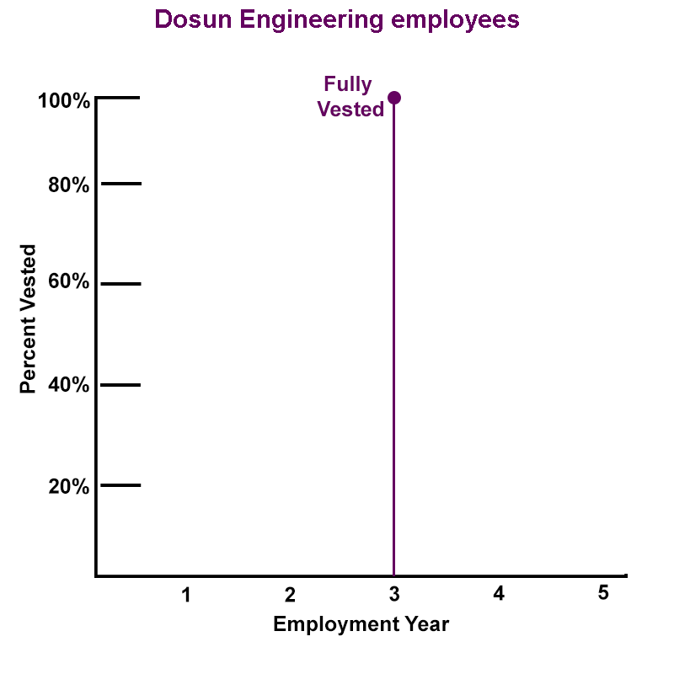

To be considered a qualified retirement plan under ERISA, a retirement plan must (choose all that apply)
Favor highly compensated employees
Provide certain reports to governmental agencies
Allow plan participants to be immediately vested in employer contributions
Submit
The following companies have qualified retirement plans for their employees. Select the correct type of vesting schedule for each example.

At Teldar Company, employees become 25% vested in Teldar’s contributions at the end of Year 1, 50% vested at the end of Year 2, 75% vested at the end of Year 3, and 100% vested at the end of Year 4.
^{Cliff vesting schedule}
^{Graded vesting schedule}
At the Portrait Company, employees become completely vested in retirement benefits funded by Portrait’s contributions at the end of year 3. Before that time, they have no vested interest in Portrait’s contributions.
^{Cliff vesting schedule}
^{Graded vesting schedule}

Defined Benefit and Defined Contribution Retirement Plans

Learning Objective
Distinguish between defined benefit and defined contribution retirement plans.

Types of Qualified Retirement Plans

Qualified employer-sponsored retirement plans are generally divided into two types:
- A defined benefit (DB) plan, often referred to as a pension plan, states the amount of the periodic benefit each plan participant will receive at retirement. A formula in the plan typically provides either a dollar amount or a percentage amount according to years of service or other objective factors.
- A defined contribution (DC) plan specifies the contributions that the plan sponsor agrees to make to the plan. The benefit that a participant will receive is not determined in advance of the participant’s retirement but depends on the investment performance of the funds in the plan.

Defined Benefit/Pension Plan

Carla says, "One of the great things about The Stetson Company is that they still offer a pension plan. That’s a defined benefit plan that will provide me a monthly income starting at my retirement and continuing for the rest of my life—in other words, a pension."

Defined Benefit (DB) Plans

Key features:
- The plan sponsor must set aside enough money to fund the promised benefits—the formula does not tell the sponsor how much that will cost.
- The plan sponsor is obligated to fund, in advance, at least a portion of the plan's specified benefits each year.
- The plan sponsor may deduct the amount it contributes on behalf of plan participants from its current taxable income as a business expense in the year it makes the contributions.
- The plan sponsor assumes all investment risk.
- The plan participant does not make contributions.
The plan sponsor must choose a funding vehicle for investing the retirement plan’s assets. Insurers offer a variety of funding vehicles, including group annuities.

Carla says, "There are several different defined benefit formulas—and you tend to need a math degree to understand them. In Stetson’s pension plan, the pension benefit is based on the employee’s salary in the years just prior to retirement and how long the employee worked at the company."

Defined Benefit Formula

The longer an employee works for a company and the higher his salary, the higher the monthly income payment.
That means the pension benefit is based on the employee’s highest-earning years.

Advantages of DB Pension Plans

A DB plan is a terrific benefit for employees! Here’s why:
- Plan participants do not have to contribute their own money to the plan; only plan sponsors make contributions
- A plan participant typically gets a monthly retirement benefit—usually provided by an annuity
- The retirement benefit payments are guaranteed to continue for the participant’s lifetime
- Investment professionals manage and allocate pension fund investments
- A participant’s benefit is guaranteed up to certain limits in the United States by the Pension Benefit Guaranty Corporation (PBGC), a unit of the federal government that insures pension plans
But many companies have abandoned or frozen their existing DB plans, and hardly any employers are establishing new DB plans. Why?

Disadvantages of DB Plans

- DB plans are typically expensive to set up and administer—even for the largest companies.
- Plan costs are determined by actuarial assumptions relating to employer contributions and investment earnings that are difficult to predict from year to year. In years in which plan investments don’t perform as well as expected, the employer has to contribute more to the plan than anticipated, which can hurt the company’s financial results.
- DB benefits aren’t portable; however, an employee will receive vested benefit amounts from the employer upon retirement.
- DB benefit calculations are difficult for employees to understand.

Shift From Defined Benefit Plans to Defined Contribution Plans
See as this industry expert explains why most companies have replaced their defined benefit pension plans with defined contribution plans and how the insurance industry has responded to the shift.
Open Transcript

Defined Contribution (DC) Plans
Because companies want to offer a retirement benefit to their employees, but may not want to set up a DB plan, many have turned to defined contribution (DC) plans.
Remember, a DC plan specifies only what goes into the plan, not what will be paid out. The exact retirement benefit isn’t known until the employee retires and begins withdrawing funds.

Characteristics of DC Plans

- The plan sponsor establishes an account for each employee.
- Employer contributions on behalf of an employee are allocated to that employee’s account.
- Investment earnings as well as expenses, are also allocated to a participant’s account.
- The amount of a participant’s retirement benefit depends on the participant’s account balance and so cannot be accurately predicted very far in advance of the retirement date.

Tax Advantages of Defined Contribution Plans
There are limits, of course, but generally:
- A plan sponsor may deduct the amount it contributes on behalf of plan participants from its current taxable income as a business expense
- Plan participants’ contributions are typically made on a tax-deferred basis—which means they don’t pay taxes on contributions or earnings until they are withdrawn from the plan
- A plan sponsor’s contributions on behalf of a participant are not considered current taxable income to the participant until the participant withdraws those contributions from the plan.
Some DC plans include a Roth contribution feature that allows employees to make after-tax contributions in place of all or part of pre-tax contributions. We’ll explain Roth contributions later in the lesson.

Do other countries provide tax advantages for private pension plans?
Countries use different methods of providing tax advantages.
For each of the methods below, an “E” stands for “exempt” and a “T” stands for “taxed”. The first letter indicates the tax status of “contributions”, the second letter indicates the tax status of “investment income and capital gains”, and the third letter indicates the tax status of “benefits”.
The three primary methods of providing tax advantages are:

EET System
Exempt | Contributions
Exempt | Investment income and capital gains
Taxed | Benefits

TET System
Taxed | Contributions
Exempt | Investment income and capital gains
Taxed | Benefits

TEE System
Taxed | Contributions
Exempt | Investment income and capital gains
Exempt | Benefits
The majority of countries use some variation of the EET system. For example, the tax treatment of contributions may vary depending on the source of the contribution—whether made by employee or employer. Most countries exempt from taxation investment income and capital gains. Source

Defined Contribution Plans vs. Defined Benefit Plans
Here are ways that DC plans differ from DB plans.
- DC participants typically control the investment of their retirement funds but also assume the investment risk
- DC participants have the potential of a higher investment return than is generally earned by a DB plan
- DC participants can often contribute, within limits, extra amounts of money to boost the balance of their accounts
- DC participants may have emergency access to the funds in their accounts before retirement

The Stetson Company has a qualified defined benefit pension plan. Select all true statements about a defined benefit pension plan.
Stetson sets up an individual account for each employee.
If investments perform poorly, Stetson must set aside additional amounts to ensure that the plan is funded.
The amount of each plan participant’s retirement benefit is determined in advance.
Plan participants can make contributions to the plan.
Plan participants direct the investment choices.
Submit
Indicate whether a company looking for the following advantages would be better off selecting a defined benefit or a defined contribution retirement plan.

More predictable costs for the employer
^{DC}
^{DB}
Government guarantees for retirement benefits in the event the retirement plan terminates without sufficient money to pay retirement benefits
^{DC}
^{DB}
Guaranteed retirement income for life
^{DC}
^{DB}

Defined Contribution (DC) Plans

Learning Objective
Identify and describe different types of defined contribution plans.

If you live in the United States, chances are you’ve heard of a 401(k). A 401(k) is an example of a
^{Defined contribution plan}
^{Defined benefit plan}

Types of Defined Contribution Plans

There are several types of defined contribution plans that differ in pretty significant ways. Stetson’s plan is a common type of defined contribution plan known as a 401(k) plan. Other types of defined contribution plans include profit sharing plans and stock bonus plans. Let’s take a closer look at the traditional 401(k) plan first.

Traditional 401(k) plans

A 401(k) plan allows employees to make pre-tax contributions to the plan. Employees enter into a salary reduction arrangement so that the employer can deduct contributions from their salaries.
(Below, click or touch the arrow to the right.)

Jerome says, "Salary reduction? That sounds a little scary. We need every bit of my salary to make ends meet. I might have to pass on this particular benefit."

Pre-Tax Contributions

First, employee contributions to a traditional 401(k) are pre-tax contributions. That means the contributions come out of the employee’s salary before income taxes are calculated, so they’re not taxable in the year they are made.
Pre-tax contributions reduce the amount of the employee’s taxable income and therefore reduce the employee’s current tax bill.

Matching Contributions

Second, by contributing to the plan, an employee may receive employer matching contributions. For example, Stetson will contribute to Jerome’s 401(k) account, but only if he contributes.
The employer contribution can equal the employee's contribution, or be a percentage of that amount, subject to a specified maximum.
Employer contributions are not considered current taxable income to the participant until the participant withdraws them from the plan.

401(k) Matching Contributions
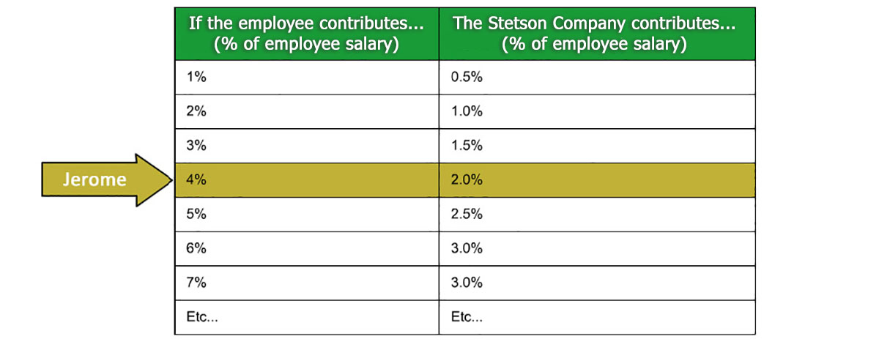
The Stetson Company matches 50% of employee contributions up to 6 percent of the employee’s salary. So if Jerome contributes 4 percent of his salary, Stetson contributes 50% of that, or 2 %.
(Click or touch the arrow to the right.)

Jerome says, "So, if I don’t contribute, I’m actually giving up money that Stetson is willing to pay me."

Participants in a traditional 401(k) plan choose how to invest the amounts in their retirement accounts. Do you think participants pay taxes on their investment earnings?
Yes, taxes are paid on investment earnings in the year in which they occur
Yes, taxes are paid on investment earnings when they are withdrawn from the plan
No, participants never pay taxes on qualified retirement plan investment earnings
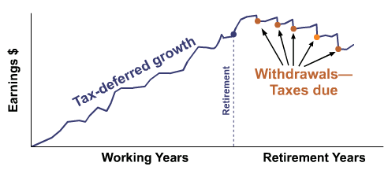
Tax deferral is a good thing. Earnings grow faster than if they were taxed each year.
And, if the participant is in a lower tax bracket after retirement (which is common), the earnings will be taxed at a lower rate.

401(k) Withdrawals

At retirement, the employee pays income taxes on pre-tax contributions and investment earnings when he withdraws them from the plan.
Early withdrawals—before age 59½ —are possible, but the participant usually incurs an additional penalty tax.
So I can't access my money without penalty before retirement?

Start

401(k) Loans

401(k) plans typically allow a participant to take loans from his vested account balance, subject to regulatory and plan limits. Typically the loan interest rate is low, for example, prime rate + 1%.
However, the participant must repay the loan with after-tax dollars through payroll deductions.

In a 401(k) plan, an employee can contribute to the plan only if the employer contributes to the employee’s account.
^{True}
^{False}
Carla Abernathy elected to defer 8% of her wages each pay period to Stetson’s qualified defined contribution retirement plan. Stetson contributes 4% to the retirement plan on behalf of Carla. By deferring a part of her compensation, Carla’s current tax liability will
^{Increase}
^{Decrease}
Carla must pay taxes each year on the amount that Stetson contributes on her behalf to her qualified retirement plan.
^{True}
^{False}
Carla will have to pay taxes on her investment earnings
^{In the year the earnings occur}
When she withdraws them from the plan
^{Never}

Jerome says, "What was that about a “traditional” 401(k) plan? Is there another type?"

Roth 401(k) Contributions
Starting in 2006, U.S. employers were permitted to add Roth 401(k) features to their 401(k) plans, in which participants can elect to have all or a portion of their contributions deducted from their gross income after taxes. With this feature, employees can receive tax-free distributions of contributions and earnings at retirement.

Tax Comparison
Traditional 401(k) employee contributions are pre-tax—that is, contributions are deducted from an employee’s earnings before income taxes are calculated. However, amounts are taxed upon withdrawal.
Roth 401(k) employee contributions are deducted from an employee’s earnings after taxes—that is, taxes are paid before the contribution is calculated. But, amounts generally aren’t taxable when withdrawn.
So, with either type, you’re going to pay taxes on your contributions, it’s just a matter of when.
Right.
- Roth 401(k) plan contributions are taxed sooner.
- Traditional 401(k) contributions are taxed later.

Traditional 401(k) vs. Roth 401(k)
 | Traditional 401(k) | Roth 401(k)
Employee Pre-Tax Contributions? | Yes, subject to limits | No
Employee Post-Tax Contributions? | May be allowed, in addition to pre-tax | All contributions are post-tax, subject to limits
Income tax paid on contributions when they are withdrawn? | Yes, on pre-tax contributions | No
Income tax paid on investment earnings when they are withdrawn? | Yes | No, provided certain conditions are met

A 401(k) plan with a Roth feature may offer an advantage that a traditional 401(k) plan doesn’t offer. What do you think it is?
A plan with a Roth feature offers tax-free accumulation of investment earnings
A plan with a Roth feature offers a tax-deferred accumulation of investment earnings
A plan with a Roth feature guarantees no loss of principal in a participant’s account balance

Tax-Free Withdrawals
Roth 401(k) investment earnings can be withdrawn tax-free and penalty-free IF
• The account has been open for at least five years, AND
• The account owner
- Is at least age 59 ½ OR
- Has died OR
- Has become disabled OR
- Is a first-time homebuyer.

Other 401(k) Type Plans
Two types of plans similar to the 401(k):
- 403(b) plan—primarily for school and college employees and many non-profit organizations
- 457 plan—primarily for government employees

Profit Sharing Plans

Now let’s talk about those other two types of defined contribution plans.
A profit sharing plan is a DC plan in which employer contributions to employees’ retirement accounts are based on the company’s profits.
- The amount of contributions varies from year to year.
- Contributions are at the employer’s discretion; some years, there may be no contributions.
- To be a qualified plan, a profit sharing plan must have contributions that are substantial and recurring.

Stock Bonus Plans

A stock bonus plan is a DC plan in which the plan sponsor makes contributions on behalf of participants in the form of the corporation's stock.
- Contributions are not tied to corporate profits
- The value of the stock fluctuates

Identify each type of plan by the description.

Acme Corporation’s plan allows full-time employees to make pre-tax contributions from their salary. Acme matches employee contributions up to a maximum of 3% of each employee’s salary.
^{Profit sharing plan}
^{Stock bonus plan}
^{Pension plan}
^{401(k) plan}
Beacon Corporation contributes to its plan in the form of shares of the corporation's stock.
^{Profit sharing plan}
^{Stock bonus plan}
^{Pension plan}
^{401(k) plan}
Compton Company’s plan provides retired employees with a lifetime monthly income benefit.
^{Profit sharing plan}
^{Stock bonus plan}
^{Pension plan}
^{401(k) plan}
Denton Corporation’s plan contributions come from corporate profits, and the company can decide to make no contributions when profits are weak.
^{Profit sharing plan}
^{Stock bonus plan}
^{Pension plan}
^{401(k) plan}

Retirement Plans for Small Business Owners and the Self-Employed

Learning Objective
List and describe retirement plans available to small employers in the United States.

Many small business owners and self-employed people are discouraged by the costs and complexity of setting up and managing a qualified retirement plan.
For many employers, the ERISA requirements they must meet to get the tax benefits are a big deal.
Burdensome. Expensive. Complicated.
So, can only big companies have retirement plans?
NO!

Small businesses and the self-employed have several retirement plan options that do not have to comply fully with ERISA, including
- SEP
- SIMPLE IRA
- SIMPLE 401(k)
- Keogh Plan

SEP
A SEP (simplified employee pension) is a plan that allows a business of any size (including the self-employed) to make contributions up to a stated limit to an IRA for each participating employee.

SEP = Simplified Employee Pension and IRA = Individual Retirement Arrangement
Key points:
- A SEP is funded by employer contributions only
- An employee is always 100% vested in his SEP IRA

SIMPLE IRA
A SIMPLE IRA is a tax-advantaged retirement plan for employers with 100 or fewer employees (including the self-employed). SIMPLE IRAs include employee and employer contributions, and they use IRAs to fund the benefits for plan participants.

Key points:
- SIMPLE IRA is funded by both employer and employee contributions
- An employee is always 100% vested in all SIMPLE IRA contributions
- Employer contributions are excluded from the employee’s current taxable income

SIMPLE 401(k)

A SIMPLE 401(k) is a simplified 401(k) plan for employers with 100 or fewer employees.
Key points:
- Plan functions much like a traditional 401(k) plan with employer and employee contributions up to a stated maximum
- Employer contributions are excluded from the employee’s current taxable income.

Keogh Plan
A Keogh plan is a qualified retirement plan intended primarily for self-employed people. A Keogh plan can be set up as either a DC plan or a DB plan, although most are DC plans.
Key points:
- The business or individual makes annual tax-deductible contributions, subject to certain limits and conditions
- Investment earnings are tax-deferred
- Contribution limits are higher than for SEP and SIMPLE plans, but Keoghs are more complex to set up and administer

Identify the plans below that are examples of simplified retirement plans intended for small employers or self-employed persons. Choose all that apply.
^{Keogh plan}
^{SIMPLE 401(k)}
^{SEP}
^{Section 457 plan}
Submit
Which plan allows employer contributions only?
^{SEP}
^{SIMPLE IRA}
^{SIMPLE 401(k)}

